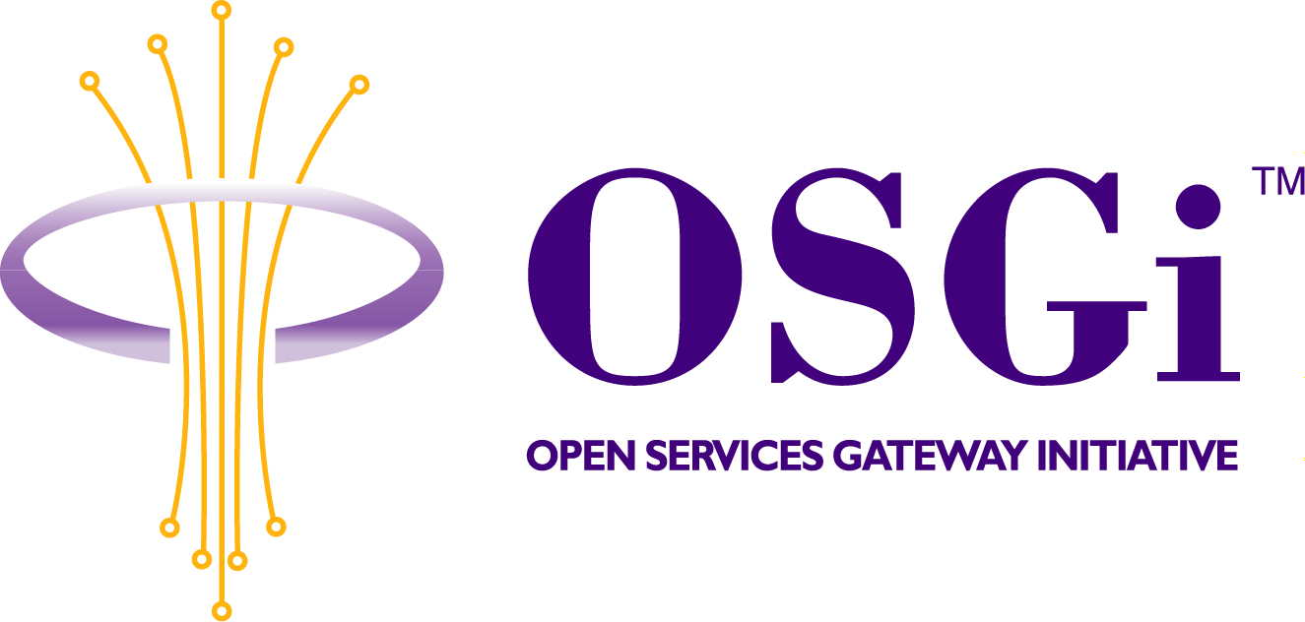
UPnP Control Point and UPnP Export Manager API
Confidential, Draft
RFP 23
7 Pages
Abstract
Discovery and Control of UPnP (Universal Plug and Play) Devices and Services from within an OSGi Framework. Using the OSGi Device Driver model. Exporting OSGi Services as UPnP Devices.

Document Information

Table of Contents
0 Document Information 2
0.1 Table of Contents 2
0.2 Status 2
0.3 Acknowledgement 2
0.4 Terminology and Document Conventions 3
0.5 Revision History 3
1 Introduction 4
2 Motivation and Rationale 4
3 Technical Discussion 5
3.1 – UPnP Control Point. 5
3.1.1 - Discovery 5
3.1.2 – Description 5
3.1.3 – Control 5
3.1.4 – Events 5
3.1.5 – Presentation 5
3.2 – UPnP Export Manager 5
3.2.1 – Overview 5
4 Security Considerations 6
5 Document Support 6
5.1 References 6
5.2 Author’s Address 6
5.3 Acronyms and Abbreviations 6
5.4 End of Document 6

Status
This document specifies UPnP Control Point and UPnP Export Manager APIs for the Open Services Gateway Initiative, and requests discussion and suggestions for improvements. Distribution of this document is unlimited within the OSGi organization.

Acknowledgement

Terminology and Document Conventions
The key words "MUST", "MUST NOT", "REQUIRED", "SHALL", "SHALL NOT", "SHOULD", "SHOULD NOT", "RECOMMENDED", "NOT RECOMMENDED", "MAY" and "OPTIONAL" in this document are to be interpreted as described in [1].
Source code is shown in this typeface.

Revision History
The last named individual in this history is currently responsible for this document.

Revision | Date | Comments
Initial | Jul 06 2001 | Plamen Kosseff, ProSyst Software AG  p_kosseff@prosyst.bg  Pavlin Dobrev, ProSyst Software AG  p.dobrev@prosyst.com

Introduction
Universal Plug and Play (UPnP) is an architecture for pervasive peer-to-peer network connectivity of intelligent appliances, wireless devices, and PCs of all form factors. It is designed to bring easy-to-use, flexible, standards-based connectivity to ad-hoc or unmanaged networks whether in the home, in a small business, public spaces, or attached to the Internet. Universal Plug and Play is a distributed, open networking architecture that leverages TCP/IP and the Web technologies to enable seamless proximity networking in addition to control and data transfer among networked devices in the home, office, and public spaces.
UPnP is more than just a simple extension of the plug and play peripheral model. It is designed to support zero-configuration, "invisible" networking, and automatic discovery for a breadth of device categories from a wide range of vendors. This means a device can dynamically join a network, obtain an IP address, convey its capabilities, and learn about the presence and capabilities of other devices. DHCP and DNS servers are optional and are used only if available on the network. Finally, a device can leave a network smoothly and automatically without leaving any unwanted state behind.
UPnP leverages Internet components, including IP, TCP, UDP, HTTP, and XML. Like the Internet, contracts are based on wire protocols that are declarative, expressed in XML, and communicated via HTTP. IP internetworking is a strong choice for UPnP because of its proven ability to span different physical media, to enable real world multiple-vendor interoperation, and to achieve synergy with the Internet and many home and office intranets. UPnP has been explicitly designed to accommodate these environments. Further, via bridging, UPnP accommodates media running non-IP protocols when cost, technology, or legacy prevents the media or devices attached to it from running IP.
What is "universal" about UPnP? No device drivers; common protocols are used instead. UPnP networking is media independent. UPnP devices can be implemented using any programming language, and on any operating system. UPnP does not specify or constrain the design of an API for applications running on control points; OS vendors may create APIs that suit their customer's needs. UPnP enables vendor control over device UI and interaction using the browser as well as conventional application programmatic control.

Motivation and Rationale
UPnP is on its way to becoming widely used Discovery and Control protocol. In order OSGi-complaint gateways to be ready to meet future customer needs in that direction, there is a need for standardized API which enables OSGi Services to interact with UPnP Network either using UPnP Devices and Services or to be able to act as one. The Device Driver Model is the natural way for UPnP Devices to be made available to OSGi Services.

Technical Discussion

– UPnP Control Point.

- Discovery
The UPnP Control Point MUST be able to discover all UPnP compliant devices within the accessible network scope.

– Description
The UPnP Control Point MUST be able to understand any Universal Plug and Play Device Architecture v1.0 compliant description documents.

– Control
The UPnP Control Point MUST be able to control any UPnP Devices (standard defined by UPnP Forum working committee or non-standard defined by UPnP Vendor) available on the network.

– Events
The UPnP Control Point MUST be able to receive events and notifications from any known UPnP Devices (standard defined by UPnP Forum working committee or Non-standard defined by UPnP Vendor) available on the network.

– Presentation
The UPnP Control Point MAY provide way for viewing presentational HTML of the UPnP Devices

– UPnP Export Manager

– Overview
The UPnP Export Manager MUST provide API for OSGi Services to export their functionality as UPnP Devices and Services.
APIs MUST be transparent to the OSGi Service. OSGi Services MUST not be aware of any underlying network and protocol specific requirements. The UPnP Export Manager MUST be able to generate Description XML Documents. OSGi Services must provide any needed resources such as presentational HTML, any resources needed for that document, icon images and any other resources that UPnP Export Manager cannot generate at run-time.

Security Considerations
Any possible security vulnerability depends underlying OS and Network.

Document Support

References
- Bradner, S., Key words for use in RFCs to Indicate Requirement Levels, RFC2119, March 1997.
- Universal Plug and Play Device Architecture

Author’s Address

Name | Plamen Kosseff
Company | ProSyst Software AG
Address | Gustav-Heinemann-Ufer 54, 50968 Cologne, Germany
Voice | +359 2 963 10 04
e-mail | p_kosseff@prosyst.bg

Name | Pavlin Dobrev
Company | ProSyst Software AG
Address | Gustav-Heinemann-Ufer 54, 50968 Cologne, Germany
Voice | +359 2 963 10 04
e-mail | p.dobrev@prosyst.com

Acronyms and Abbreviations

End of Document

